
Cobretti Viper V8

Cobretti Engineering is owned and run by Robert Busbridge, and he is a registered owner of the Viper trademark in the U.K. after 16 years of irritating legal issues, Daimler Chrysler, now call their car the Dodge SRT10.

The Viper, Cobra replica, has been available for nearly 23 years, and descends originally from the Sheldonhurst Cobra replica produced up to 1985, then the Brightwheel Viper, produced until 1989, and from then the Cobretti Viper. It retains the unique wide front wheel arch treatment from the Sheldonhurst, giving the stance of the Viper a very menacing frontal appearance, plus ensuring immense cornering stability.

The ride quality is extremely compliant ideal for long distant cruising, absorbing potholes without rattling your teeth, this can be adjusted, so if you want to go racing, no problem.
A beautifully prepared Cobretti Viper V8 can be a devastating contender and can give any other quality Cobra replica a run for its money, on the track the Viper is awesome and can compete with the rest of them.

There are many stunning factory and home built examples on the road, customers detailing them with their own specifications, choice, of trim, and engines, inc Rover 3500 cc, Chevy 350 cu in, up to big block American V8’s and the Jaguar V12.

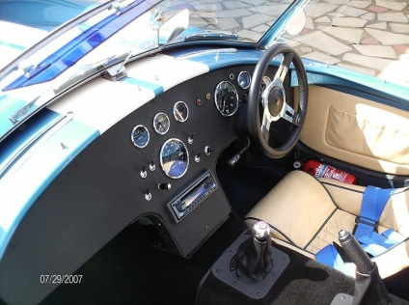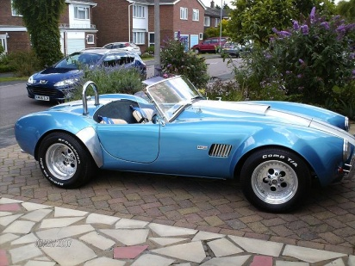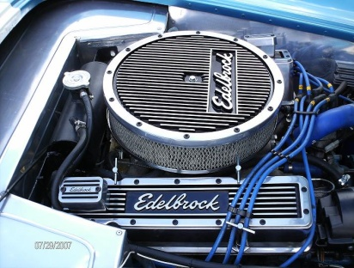

The chassis is still made to the same exacting standards with safety and quality of ride foremost, with a track of 59.5in, and a wheel base of 90.5in, having substantial 80mm, x 40mm, x2.5mm, steel box section for the main chassis rails, then clad in 14 gauge steel sheeting to floor, bulkheads, and tunnel.

All bracketry for windscreen, door hinges, and bumpers bolt to the main chassis, ultimately forming an immensely safe, rigid, and stiff, albeit slightly heavier chassis, but fitted with a strong AmericanV8 this poses no problems. (see website Car Builder June 1991 Cobretti Viper v Landrover for crash test)

The suspension system is of Jaguar XJ6 origin, with independent front wishbone configuration, fitted with purpose built coil over shock absorbers. The rear XJ6 I.R.S. and Differential is of standard construction, and bust proof (no shortening of drive shafts or wishbones), a standard diff ratio of
3.31-1, or a limited slip diff with a ratio of 2.88-1, fitted with 4 off coil over adjustable shock absorbers.

The braking system is Jaguar XJ6 servo assisted with 4 pot calipers and vented disks on the front and inboard disks at rear affording dynamic braking efficiency per ton.
The steering is light and responsive, using a modified XJ6 steering column, and a modified Fiesta steering rack.

The body shell is of GRP construction with a 4 to 6 oz lay-up, strengthened with core mat in certain areas. Bonnet, boot, and doors, are all double skinned forming smooth inner surfaces. Bonnet hinge, door hinge, and door lock plates, are encapsulated within the fibre glass panels.

The body kit is supplied with various grp panels boot liner, wheel arch panels, which have to be fibre glassed to the main body shell, and chassis, once mounted to the chassis it forms an immensely strong bonded unit. Although the body can be supplied with various gel coat colors, it is highly recommended to finish the body in a high gloss painted surface for the ultimate look.

Price of Viper V8 Body/ Chassis £ 4,250.00

…….Contact Details…….

Robert Busbridge, Cobretti Engineering, 22 Hillfield Avenue, Morden, Surrey, SM4 6BA

0208 395 0109bob@cobrettiviperv8.com http://www.cobrettiviperv8.com

